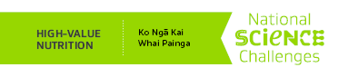**

**High-Value Nutrition Best Research Team Workshop**

**Call for Participation Application Form**

Please email your expression of interest **by 20 July 2018** using this application form to [hvn@auckland.ac.nz](mailto:hvn@auckland.ac.nz)

|  |
| --- |
| **Section 1: Please provide a copy of your CV, using the template provided** |
| *Maximum of five pages* |
| **Section 2:** |
| *Please describe how you can contribute to HVN within the priority health themes or Consumer Insights supporting platform. This may be through a new idea that enriches the science excellence of the tranche two research plans, a particular skill set that complements the team or provides the opportunity for additional science stretch. Include how your idea supports the Vision mātauranga framework.*  *Word limit: 600 words; please note if you are selected to participate in the workshops, you will be asked to present your idea or skill set in more detail.* |
| **Section 3: Conflict of Interest** |
| *Please declare any conflicts of interest.* |

Thank you for your application.